**Foster Care Fortnight**  
Recruitment of new Foster Carers

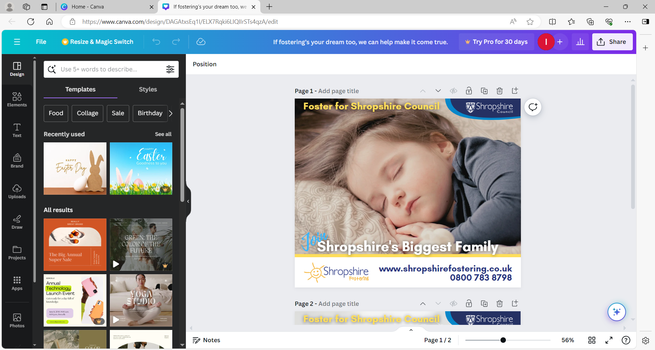

Communications Toolkit

**About this Toolkit**

Thank you for supporting our drive to recruit new foster carers from the Shropshire region.

This toolkit provides advice and information on how to raise awareness and promote these events to your audiences.

The toolkit also provides you with a range of communication materials including, articles, and social media messages for you to use and cascade to your staff, residents that you support, organisations that you work with, and the wider community.

**Background**

**Foster Care Fortnight is an annual campaign to raise the profile of fostering and show how foster care transforms lives. Foster Care Fortnight 2024 will take place from Monday 13 May - Sunday 26 May.**

Foster Care Fortnight is the UK’s biggest foster care awareness raising campaign. Established in 1997, the campaign showcases the commitment, passion, and dedication of foster carers. It also supports fostering services to highlight the need for more foster carers. Thousands of new foster families are needed every year to care for children, with the greatest need being for foster carers for older children, sibling groups, disabled children, and unaccompanied asylum-seeking children.

Running from **Monday 13 May - Sunday 26 May 2024**, our local theme this year is #ShropshiresBiggestFamily.

During Foster Care Fortnight 2024 we want to celebrate the moments that define fostering journeys, big and small. The moments that built confidence, made young people feel safe and created memories.

Throughout the fortnight we will encourage people across the community to share the information about the need for more foster carers from this region. For foster carers, this would mean sharing our social media stories and reflecting positively on Fostering in any of their own posts. E.g., about the moment they were approved as a foster carer, or the moment a young person in their care hugged them for the first time. We want to show that every moment matters in fostering.

Whether you’re a foster carer or not you are part of the local community and can make a difference to young people across the county by sharing our fostering information - we want you all to get involved in the Foster Care Fortnight celebration!!

**Press release/article**

Please use this article for newsletters, websites, staff intranets and any other appropriate communication channels you use. Feel free to also include a quote from your organisation to support the campaign.

**External (Websites, newsrooms, newsletters etc)**

**Foster Care Fortnight 2024 - Join Shropshire's biggest family and make a difference to children's lives**

Shropshire Fostering celebrates Foster Care Fortnight 2024

To celebrate Foster Care Fortnight (13 to 26 May 2024), Shropshire Fostering is holding a series of events across the county to encourage more people to consider fostering.

Foster Care Fortnight is the UK's biggest foster care awareness raising campaign, organised by The Fostering Network. It aims to showcase the commitment, passion, and dedication of foster carers and the positive impact they have on the lives of children and young people in care.

Shropshire Fostering, the fostering service of Shropshire Council, is supporting the national campaign to highlight the need for more foster carers in the county and fostering and help people discover how they can make a difference to the lives of children and young people in care.

There are currently over 700 children and young people in care in Shropshire, and many of them need a stable, loving, and supportive home with foster carers who can help them grow and thrive.

The fostering events offer people the opportunity to meet the fostering team, learn more about the role and the benefits of fostering, and ask any questions they may have. All events are free and open to anyone who is interested in fostering or wants to find out more.

# Events schedule

* Monday 13 May - Info session – Tesco Extra, Shrewsbury – 11am – 1pm
* Thursday 16 May – Shropshire Local, The Darwin Shopping Centre - 11am – 1pm
* Friday 17 May – Coffee morning – Apley on the High Street, Bridgnorth – 10am – 12pm
* Monday 20 May - Info session – Tesco Extra, Shrewsbury – 11am – 1pm
* Wednesday 22 May - Virtual session – Microsoft Teams - 6pm (1hr)
* Friday 24 May – Coffee morning – Dobbies Restaurant, Shrewsbury - 11am – 1pm

For those who prefer to meet the team online, there will also be a virtual session on Microsoft Teams, on Wednesday 22 May, at 6pm. This session will provide an overview of the fostering process, the support and training available, and the different types of fostering.

Councillor Kirstie Hurst-Knight, Cabinet Member for Children and Education, said:

" If you have ever wondered what it's like to be part of Shropshire's biggest family, now is your chance to find out! Join us for our informative events during Foster Care Fortnight 2024 and discover how you can make a difference to the lives of children and young people in care.

“Foster Care Fortnight is a great opportunity to celebrate our amazing foster carers. It is also a chance to raise awareness of the growing need for more foster carers in our region, especially for older children, sibling groups, disabled children, and unaccompanied asylum-seeking children.

“We are looking for people from all walks of life, who have a spare room and a big heart, to join Shropshire's biggest family and help us provide the best possible care for our children in need. If you are interested in fostering or want to find out more, please come along to one of our events or get in touch with our friendly team. We would love to hear from you."

Whether you are single, married, retired, or working, you could have what it takes to be a foster carer and help a child achieve their potential. Come and meet our friendly fostering team and get all your questions answered. Don't miss this opportunity to learn more about the rewarding role of fostering and how you can get involved. Book your place today and start your journey to becoming part of Shropshire's biggest family!

To book a place at one of the events, visit Foster Care Events | Fostering Information | Shropshire Fostering or call 0800 783 8798.

To find out more about fostering in Shropshire, visit Foster Care In Shropshire | Shropshire Fostering | Home or call 0800 783 8798.

**Social media**

We’ve pulled together the following messages for you to publish or share via your social media channels**. Alternatively, you can follow us and repost our messages to help amplify the campaign at:**

Shropshire Fostering Facebook

Shropshire Council Facebook

Shropshire Council Twitter

Shropshire Council NextDoor

Shropshire Council Instagram @shropshirecouncil

**Local Hashtag** #ShropshiresBiggestFamily

**National Foster Care Fortnight tag: #FCF24**

Facebook @TheFosteringNetwork | Twitter @fosteringnet | Instagram @thefosteringnetwork | LinkedIn @TheFosteringNetwork

|  |  |  |  |
| --- | --- | --- | --- |
| **Week 1** | | | |
| **Twitter**  It’s coming up to Foster Care Fortnight!  Join Shropshire Council’s Fostering team at one of their events this month and find out more how you could become part of Shropshire’s biggest family.  Find out more https://newsroom.shropshire.gov.uk/2024/05/foster-care-fortnight-2024/  #ShropshiresBiggestFamily | **Facebook/LinkedIn/Nextdoor**  It’s coming up to Foster Care Fortnight!Can you give a child a safe and loving home? If you think you’ve got what it takes to make a real difference to a child in care, then come and visit Shropshire Council’s Fostering team at their events this month and discover how you can join Shropshire’s biggest family.  Event dates and locations:  ▶️Monday 13 May: Tesco Extra, Shrewsbury from 11am to 1pm  ▶️Thursday 16 May: The Darwin Shopping Centre from 11am to 1pm  ▶️Friday 17 May: Apley on the High Street, Bridgnorth from 10am to 12pm  ▶️Monday 20 May: Tesco Extra, Shrewsbury from 11am to 1pm  ▶️Wednesday 22 May: Microsoft Teams (6pm)  ▶️Friday 24 May: Dobbies Restaurant, Shrewsbury from 11am to 1pm  If you’re curious about fostering or just want to ask questions, come and chat with Shropshire Fostering. The team offer great support, training and allowances to our foster carers.  Find out more at https://newsroom.shropshire.gov.uk/2024/05/foster-care-fortnight-2024/  #ShropshiresBiggestFamily #FCF24 #Shropshirefostering | **Instagram**  It’s coming up to Foster Care Fortnight!Can you give a child a safe and loving home? If you think you’ve got what it takes to make a real difference to a child in care, then come and visit Shropshire Council’s Fostering team at their events this month and discover how you can join Shropshire’s biggest family.  Event dates and locations:  ▶️Monday 13 May: Tesco Extra, Shrewsbury from 11am to 1pm  ▶️Thursday 16 May: The Darwin Shopping Centre from 11am to 1pm  ▶️Friday 17 May: Apley on the High Street, Bridgnorth from 10am to 12pm  ▶️Monday 20 May: Tesco Extra, Shrewsbury from 11am to 1pm  ▶️Wednesday 22 May: Microsoft Teams (6pm)  ▶️Friday 24 May: Dobbies Restaurant, Shrewsbury from 11am to 1pm  If you’re curious about fostering or just want to ask questions, come and chat with Shropshire Fostering. The team offer great support, training and allowances to our foster carers.  To find out more and book your place, search ShropshireFostering.co.uk on your search engine.  .  #ShropshiresBiggestFamily #FCF24 #Shropshirefostering |  |
| **Week 2** | | | |
| **Twitter**  Discover how you can join Shropshire’s biggest family as a foster carer!  Meet Shropshire Council’s Fostering team at their events this month and learn more about fostering in Shropshire.  Book your place and get more details here https://www.eventbrite.co.uk/o/shropshire-fostering-79908188033  #ShropshiresBiggestFamily | **Facebook/NextDoor**  Join us for Foster Care Fortnight!Do you have the heart and the space to offer a child in care a secure and loving home? If you want to make a lasting impact on a child's life, then don't miss the events that Shropshire Council's Fostering team are hosting this month. Learn how you can become part of Shropshire's biggest family.Event dates and locations:  ▶️Monday 20 May - Tesco Extra, Shrewsbury from 11am – 1pm  ▶️Wednesday 22 May - Microsoft Teams (6pm)  ▶️Friday 24 May –Dobbies Restaurant, Shrewsbury from 11am – 1pm  If you're interested in fostering or just have questions, come and talk to Shropshire Fostering. The team provide great support, training and allowances to our foster carers.You can find out more and book your place at https://www.eventbrite.co.uk/o/shropshire-fostering-79908188033#ShropshiresBiggestFamily #FCF24 #Shropshirefostering | **Instagram**  Join us for Foster Care Fortnight!Do you have the heart and the space to offer a child in care a secure and loving home? If you want to make a lasting impact on a child's life, then don't miss the events that Shropshire Council's Fostering team are hosting this month. Learn how you can become part of Shropshire's biggest family.Event dates and locations:  ▶️Monday 20 May - Tesco Extra, Shrewsbury from 11am – 1pm  ▶️Wednesday 22 May - Microsoft Teams (6pm)  ▶️Friday 24 May –Dobbies Restaurant, Shrewsbury from 11am – 1pm  If you're interested in If fostering or just have questions, come and talk to Shropshire Fostering. The team provide great support, training and allowances to our foster carers.  To find out more and book your place, search ShropshireFostering.co.uk on your search engine.  #ShropshiresBiggestFamily #FCF24 #Shropshirefostering |  |